CSE520
Samuel Marrujo
Professor Yu
Homework 1

Draw 4 polygons using Eclipse

In this homework, we are to create a cube, tetrahedron, dodecahedron, and icosahedron using Eclipse to create an Android application. I have successfully completed this task, and here is a picture of the following:

Each picture will be on a separate page as shown below.
Cube:

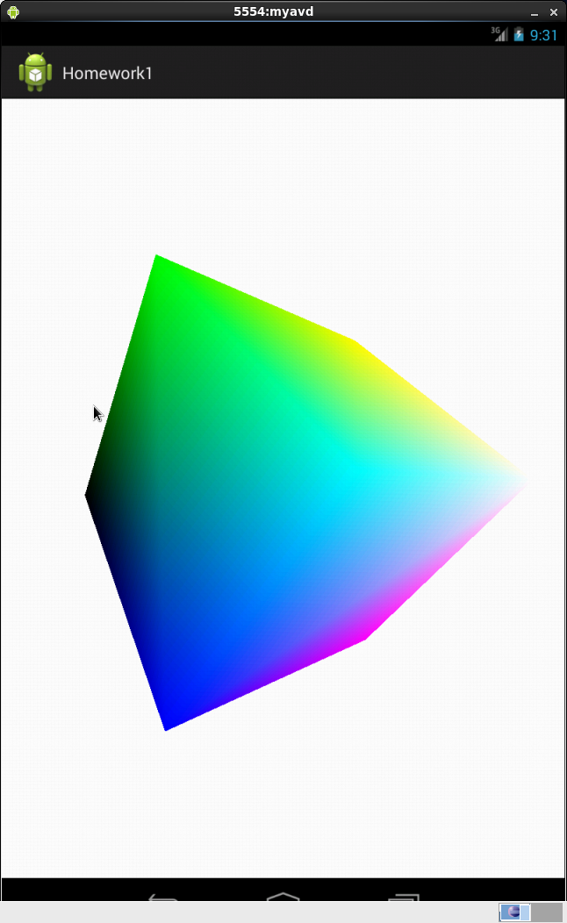
Tetrahedron:
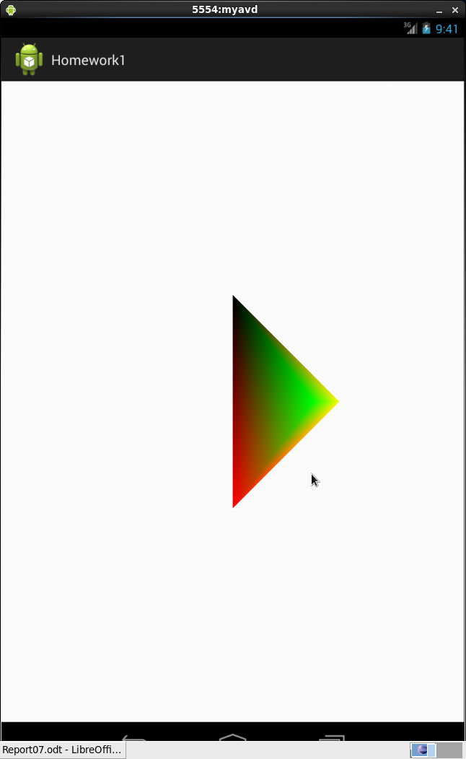
Dodecahedron:
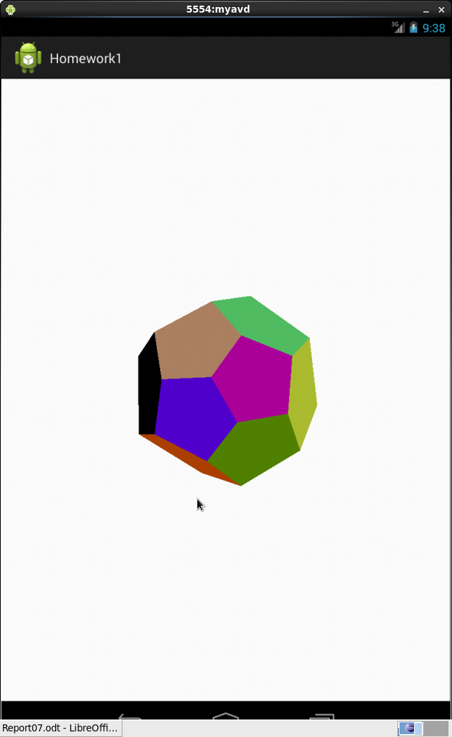
Icosahedron:
